Line Message Sending Manual

1: Go To This link <https://notify-bot.line.me/en/>

2: Make a line Group By own Line ID

2: Log In By valid --: ID (By Email and Password).

3:

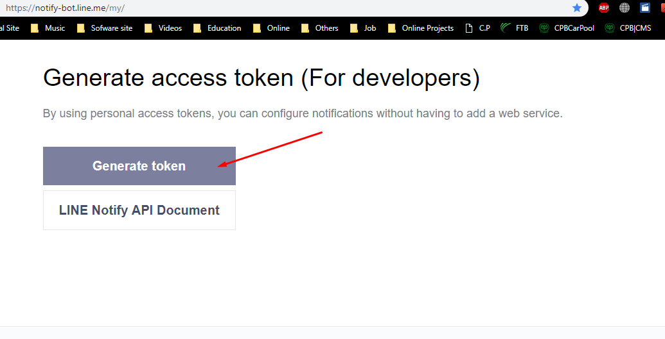

4: Search Group Name and Select that group and put a name

Hit Enter

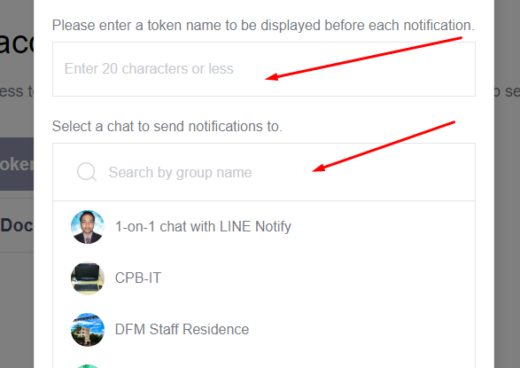

5: Copy the generated Key and Save to a text file for next time use This key is very important to send SMS

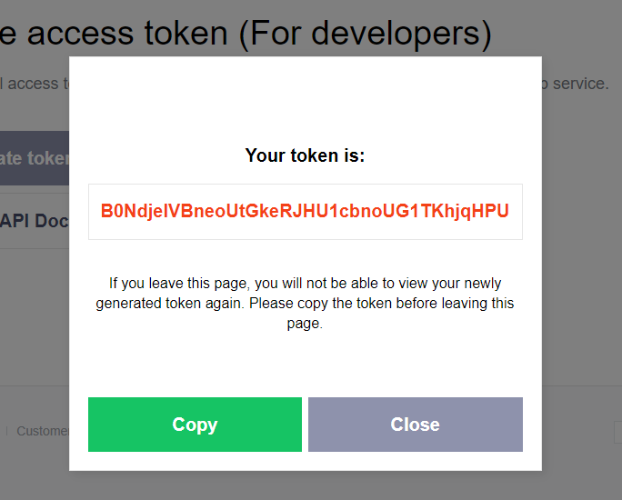

6: Replace by that token in marking area

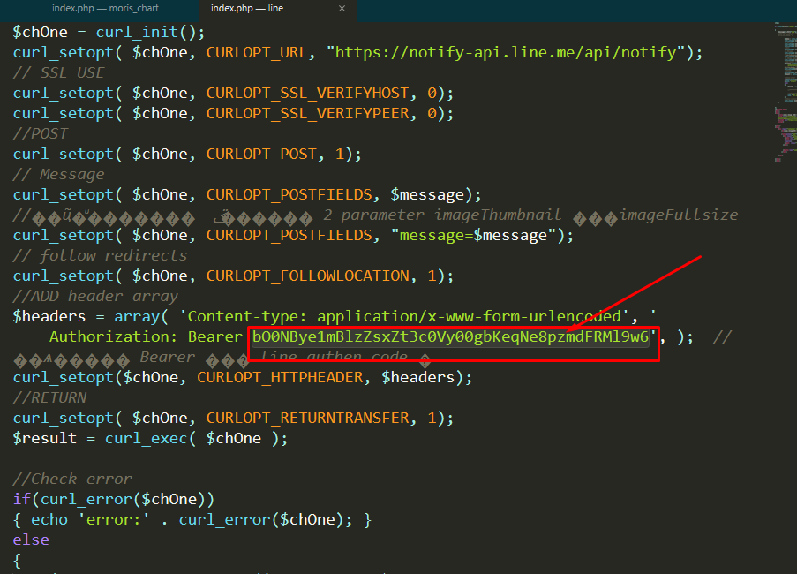

7: Set a message in message variable, And Done Open Line App

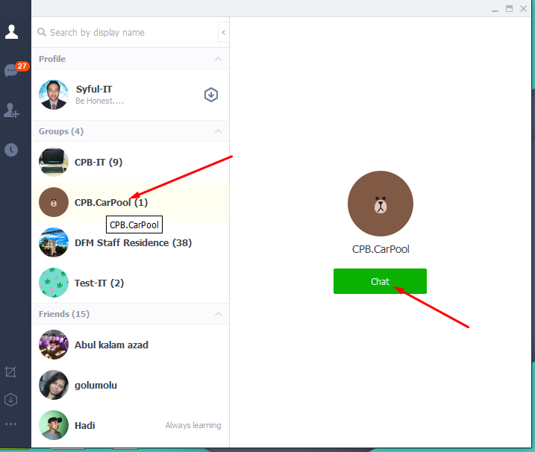

8: add friends to chat

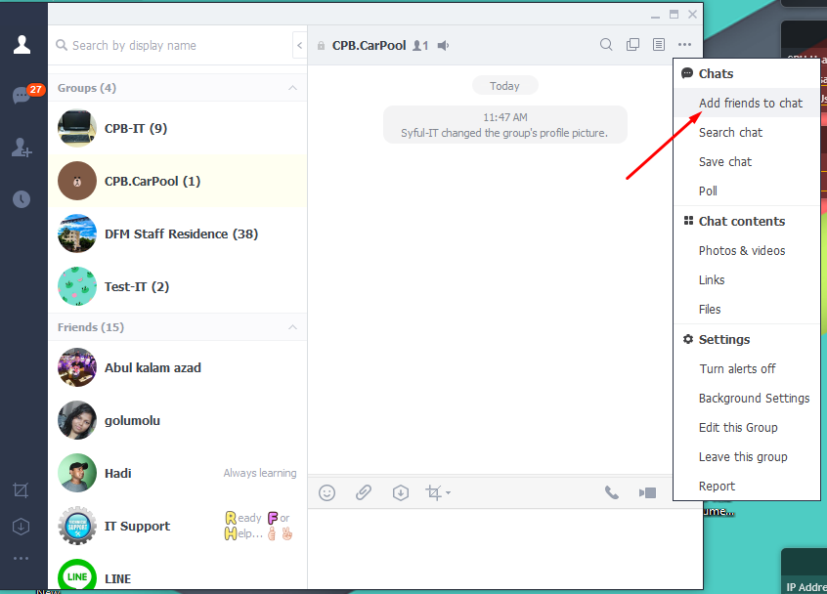

9: add line Notify as member

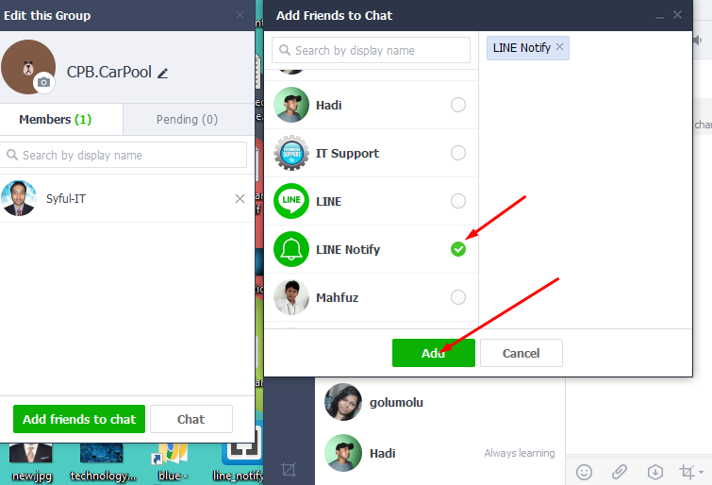

10: Now try to send SMS